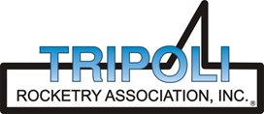
Tripoli Motor Testing Division
223 NC Highway 54 West
Chapel Hill, NC 27514
(919) 357 5681 (c)
May 9, 2022

Gary Rosenfield
RCS Rocket Motor Components, Inc.
2113 West 850 North Street
Cedar City, UT 84721

Dear Mr. Rosenfield,

The Aerotech K750ST-P motor was tested on May 7, 2022 and is in compliance with NFPA 1125. The motor is certified for hobby rocketry use by the members of the Tripoli Rocketry Association and all approving organizations with reciprocal certifying agreements.

Motor Manufacturer Aerotech Division, RCS Rocket Motor Components
Manufacturer’s Designation K750ST-P [75/1280 hardware]
Propellant Super Thunder
TMT Nomenclature 1299 K747

Diameter 2.971” 75.46 mm
Overall Length 10.5” 266.7 mm
Length Inside 9.742” 247.5 mm
Length Outside 0.758” 19.25 mm

Loaded Mass 4.2934 lb 1947.5 g
Propellant Mass 1.312 lb* 595g*
Burnout Mass 1.7185 lb 779.52 g
* data provided by manufacturer

Burn time 1.740 ± .004 sec

Total Impulse 292.42 ± 0.83 lbf.s 1298.73 ± 6.40 N.s
Max Impulse 187.87 ± 3.55 lbf 835.69 ± 15.79 N
Average Impulse 167.83 ± 0.51 lbf 746.56 ± 2.26 N
Number of Motors Tested 3

Nominal Measured
Delay Time Data n.a. n.a.

Casing Temp. [NFPA 1125 7.4.1] Passed

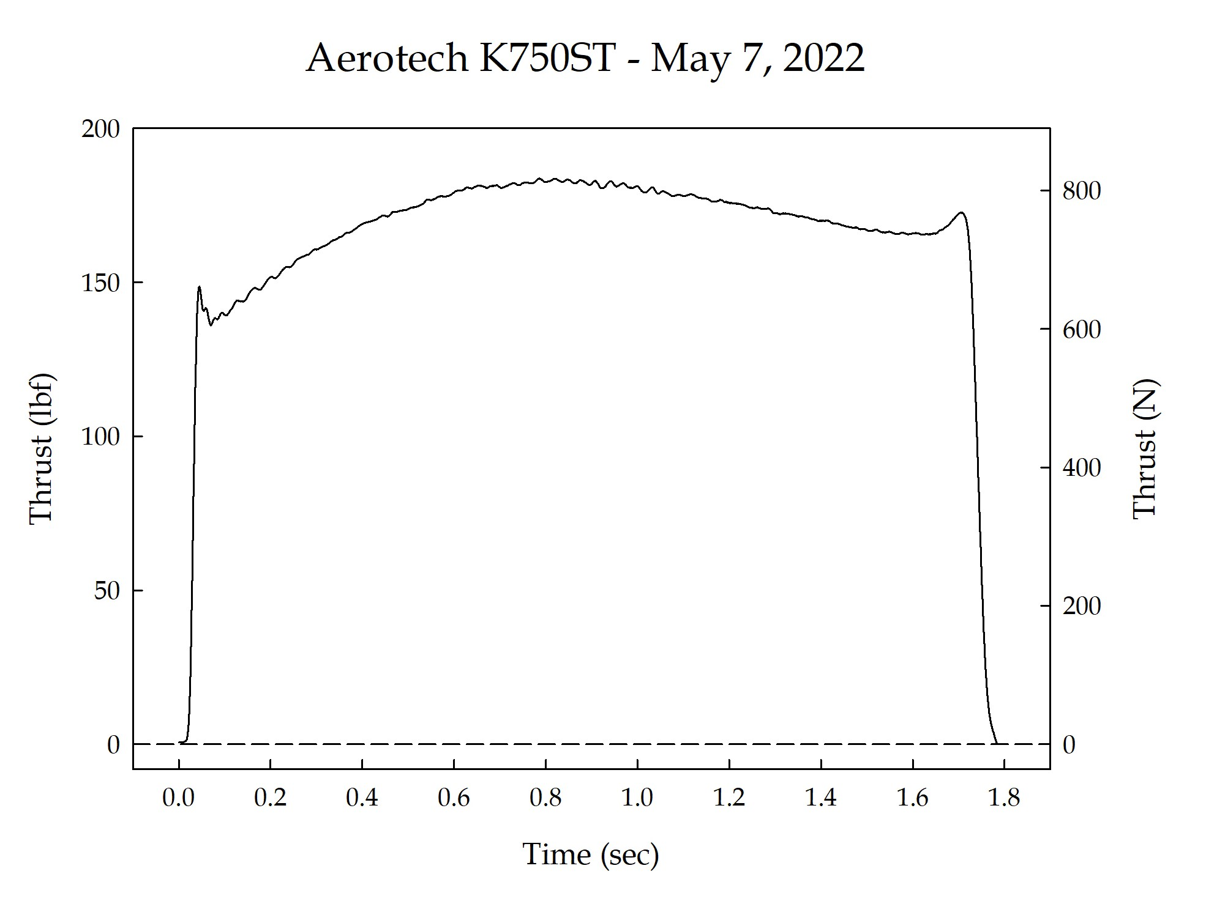

Sincerely,

Alan C. Whitmore
Chair, Tripoli Motor Testing

